**DAILY ONLINE ACTIVITIES SUMMARY**

|  |  |  |  |  |  |  |  |  |
| --- | --- | --- | --- | --- | --- | --- | --- | --- |
| **Date:** | **29/05/2020** | | | | | **Name:** | **Archana J C** | |
| **Sem & Sec** | **4th**  **‘A’** | | | | | **USN:** | **4AL18CS011** | |
| **Online Test Summary** | | | | | | | | |
| **Subject** | | **Operating System** | | | | | | |
| **Max. Marks** | | **30** | | **Score** | | | **28** | |
| **Certification Course Summary** | | | | | | | | |
| **Course** | **Python and Django full stack web developer bootcamp** | | | | | | | |
| **Certificate Provider** | | | **Udemy** | | **Duration** | | | **15 days** |
| **Coding Challenges** | | | | | | | | |
| 1. **Write a Java program to Find size of the largest ‘+’ formed by all ones in a binary matrix** 2. **Write a C Program to generate first N Armstrong Numbers** | | | | | | | | |
| **Status: Completed** | | | | | | | | |
| **Uploaded the report in Github** | | | | | **Yes** | | | |
| **If yes Repository name** | | | | | **archana_j_c** | | | |
| **Uploaded the report in slack** | | | | | **Yes** | | | |

Online Test Details: (Attach the snapshot and briefly write the report for the same)

The Online test was from module 2, which is about multithreaded programming, Processes scheduling, processes synchronization. There are 30 questions each of one marks, the duration is 45 minutes. The questions were optimal and easy. The score that I received was 28/30.

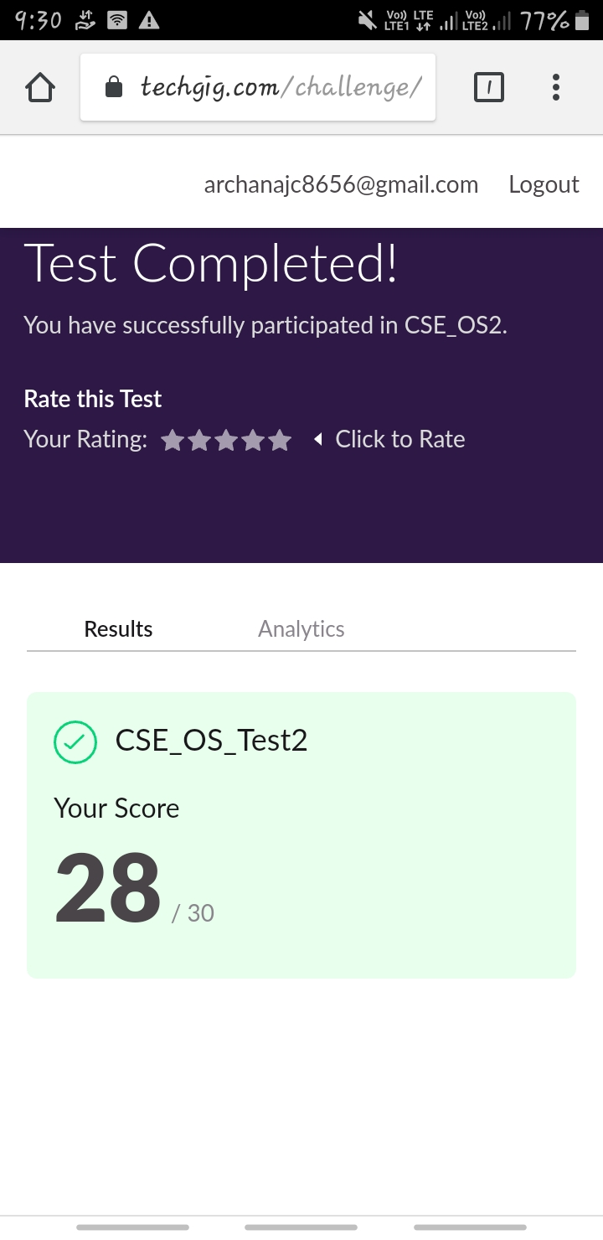

Certification Course Details: (Attach the snapshot and briefly write the report for the same)

COURSE NAME : Python and Django full stack web developer bootcamp

CERTIFICATION PROVIDERS : Udemy

Today I learnt about the introduction of the course, course overview, installation and setup, what is web, Front end introduction, and the basics of html.

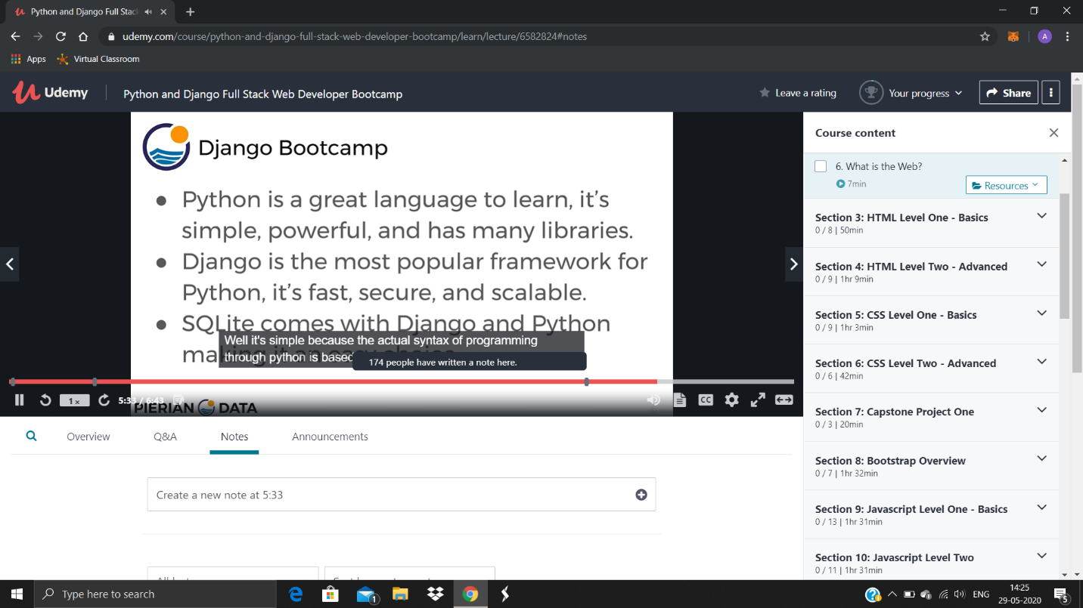

Coding Challenges Details: (Attach the snapshot and briefly write the report for the same)

Today I’m done with some c program and java program. The solution are already uploaded in github repository,

